**Backend — Lang Portal**

**Difficulty:** Level 200

**Business** **Goal:**

A language learning school wants to build a prototype of learning portal which will act as three things:

* Inventory of possible vocabulary that can be learned
* Act as a record store, providing correct and wrong score on practice vocabulary
* A unified launchpad to launch different learning apps

You have been tasked with creating the backend API of the application.

**Technical Restrictions:**

* Use SQLite3 as the database
* You can use any language or framework
* Does not require authentication/authorization, assume there is a single user

Leverage AI-coding assistants to write your backend code:

* Cursor
* Windsurf Codeium
* Github Copilot
* Amazon Q Developer
* Google Code Assist

Technical Specification

**Routes**

* **GET** /words - Get paginated list of words with review statistics
* **GET** /groups - Get paginated list of word groups with word counts
* **GET** /groups/:id - Get words from a specific group (This is intended to be used by target apps)
* **POST** /study_sessions - Create a new study session for a group
* **POST** /study_sessions/:id/review - Log a review attempt for a word during a study session

**GET /words**

* page: Page number (default: 1)
* sort_by: Sort field ('kanji', 'romaji', 'english', 'correct_count', 'wrong_count') (default: 'kanji')
* order: Sort order ('asc' or 'desc') (default: 'asc')

**GET /groups/:id**

* page: Page number (default: 1)
* sort_by: Sort field ('name', 'words_count') (default: 'name')
* order: Sort order ('asc' or 'desc') (default: 'asc')

**POST /study_sessions**

* group_id: ID of the group to study (required)
* study_activity_id: ID of the study activity (required)

**POST /study_sessions/:id/review**

**Database Schema**

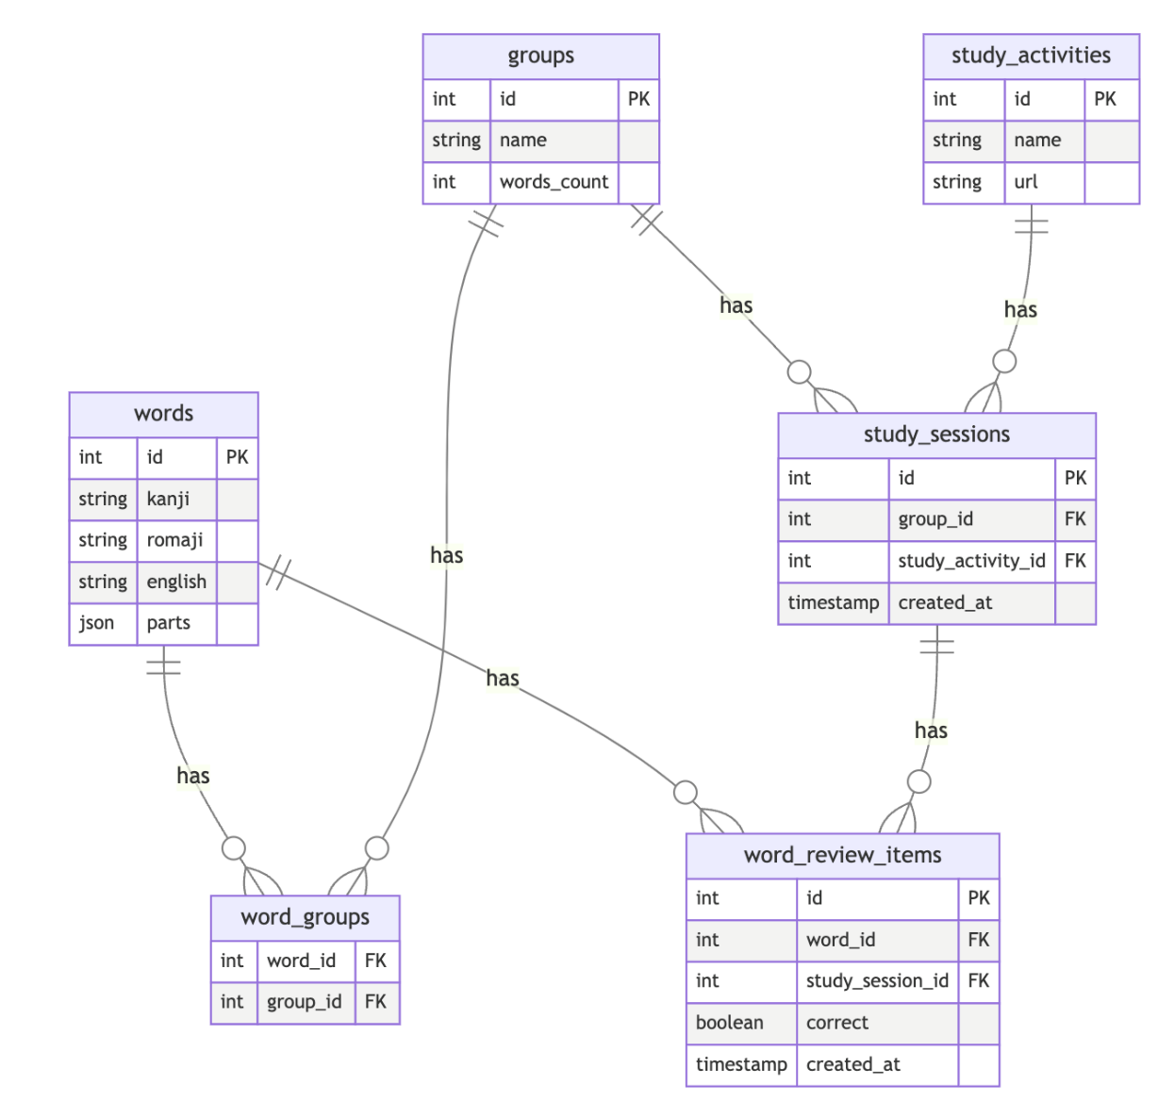

**words —** Stores individual Japanese vocabulary words.

- `id` (Primary Key): Unique identifier for each word

- `kanji` (String, Required): The word written in Japanese kanji

- `romaji` (String, Required): Romanized version of the word

- `english` (String, Required): English translation of the word

- `parts` (JSON, Required): Word components stored in JSON format

**groups —** Manages collections of words.

- `id` (Primary Key): Unique identifier for each group

- `name` (String, Required): Name of the group

- `words_count` (Integer, Default: 0): Counter cache for the number of words in the group

**word_groups —** join-table enabling many-to-many relationship between words and groups.

- `word_id` (Foreign Key): References words.id

- `group_id` (Foreign Key): References groups.id

**study_activities —** Defines different types of study activities available.

- `id` (Primary Key): Unique identifier for each activity

- `name` (String, Required): Name of the activity (e.g., "Flashcards", "Quiz")

- `url` (String, Required): The full URL of the study activity

**study_sessions** — Records individual study sessions.

- `id` (Primary Key): Unique identifier for each session

- `group_id` (Foreign Key): References groups.id

- `study_activity_id` (Foreign Key): References study_activities.id

- `created_at` (Timestamp, Default: Current Time): When the session was created

**word_review_items** — Tracks individual word reviews within study sessions.

- `id` (Primary Key): Unique identifier for each review

- `word_id` (Foreign Key): References words.id

- `study_session_id` (Foreign Key): References study_sessions.id

- `correct` (Boolean, Required): Whether the answer was correct

- `created_at` (Timestamp, Default: Current Time): When the review occurred

**Relationships**

* word belongs to groups through  word_groups
* group belongs to words through word_groups
* session belongs to a group
* session belongs to a study_activity
* session has many word_review_items
* word_review_item belongs to a study_session
* word_review_item belongs to a word

**Design Notes**

* All tables use auto-incrementing primary keys
* Timestamps are automatically set on creation where applicable
* Foreign key constraints maintain referential integrity
* JSON storage for word parts allows flexible component storage
* Counter cache on groups.words_count optimizes word counting queries